Incident Response Report

By Abu Mandam

Incident Summary
On 23-24 July 2026, Wazuh detected three separate simulated attack activities on the monitored Kali agent (192.168.56.101), generated as part of an Atomic Red Team exercise mapped to MITRE ATT&CK. The first activity, consistent with T1110 (Brute Force), was detected on 23 July at 11:26:27 when Wazuh logged repeated authentication failures and PAM (rule level 5). The second activity, consistent with T1078 (Valid Accounts), was detected roughly 24 hours later on 24 July at 11:16:08 am, when a PAM session was opened on the same agent via the su command (rule level 3). The third activity consistent with T1059 (Command and Scripting Interpreter) was detected on 23rd July at 1:44:10 pm. All events were confined to the single Kali agent host; no other hosts in the lab environment were affected. Given the low rule levels (3 and 5) and the isolated lab setting, severity is assessed as Low.

Detection and Analysis
How the T111O was detected
The T1110 activity was first surfaced in Wazuh Discover as a rule level 5 PAM login failure combined with a password-check failure, both timestamped 23 July 2026 at 11:26:27 against agent “kali” (192.168.56.101). This was the earliest alert captured for this exercise.
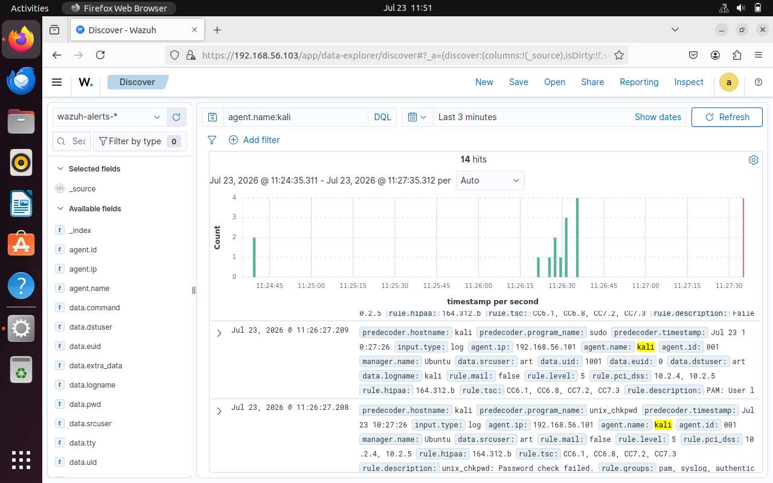
Initial Analysis
- Filtered Wazuh Discover on “agent.name:kali” to isolate all alerts tied to the test host.
- Noted multiple failed login attempts from the same device within a short period followed by one successful login, which I flagged as a brute force attempt confirming attack technique T1110 fired successfully.
- Analyzed follow up alerts that where triggered by me (T1059 Command and Scripting and T1078 Valid Accounts).

Containment and Eradication
These specific actions could be taken to effectively contain and eradicate each of these attacks BRUTE FORCE
Actions to take | Commands
Check which accounts have been compromised | sudo journalctl -u ssh --since "1 hour ago" | grep "Failed password"
Temporarily lock the targeted account | sudo passwd -l admin
Block confirmed attacking IP | sudo ufw deny from 192.168.56.101

VALID ACCOUNTS
Actions to take | Commands
Lock the account | sudo passwd –l admin
Force a password change | Sudo passwd admin
Check the accounts privileges | Sudo id admin  Sudo groups admin
Look for unauthorized SSH keys(if one is found remove that specific one rather than deleting the entire file) | Sudo ls –la/home/admin/.ssh/sudo cat/home/admin/.ssh/authorized_keys

COMMAND AND SCRIPTING
Actions to take | Commands
Review commands executed by the user | Sudo cat /home/admin/.bash_history
Look for suspicious processes | Ps aux –forest
If any suspicious processes are identified and confirmed | Sudo kill -9 J<PID>
Check whether the attacker created another privileged account | awk -F: '$3 == 0 {print $1}' /etc/passwd
Inspect the sudo group | Getent group sudo
If unauthorized accounts are discovered in the sudo group | Sudo deluser testuser sudo

Lessons Learnt
- I learned that detecting a brute-force attack is not just about seeing multiple failed login attempts. I initially focused on the number of failures, but I realized that I also needed to look at the source IP, targeted account, timing, and whether a successful login followed. This helped me understand how a seemingly simple attack can become more serious one if credentials are eventually obtained.
- This exercise taught me that a successful login does not automatically mean that the user is legitimate. I realized that valid credentials can make an attack harder to recognize because the activity can initially look like normal user behavior. I also learned that I need to pay more attention to login times, source addresses, and account activity rather than relying only on failed login alerts.
- I learned that obtaining access is only part of an attack. An attacker can use command line tools to perform actions on the system after authentication. I also realized that I need to understand normal command line activity on my systems before I can confidently identify what is suspicious.
- I also realized that there were areas where my monitoring and investigation could be improved. I need to become more comfortable reading logs, understanding normal system behavior, and correlating events instead of immediately treating every alert as an isolated incident. Going forward, I would improve the homelab by using Wazuh for centralized monitoring, enabling stronger authentication controls, and creating more specific alerts for suspicious authentication and command execution activity.

RECOMMENDATIONS
These recommendations are mapped to each attack
T1110 — Brute Force
1-Enable MFA.
2-Use strong, unique passwords.
3-Implement account lockout/rate limiting.
4-Monitor repeated failed authentication attempts.
5-Restrict unnecessary remote-access services.
T1078 — Valid Accounts
1-Enforce MFA for important accounts.
2-Apply least privilege.
3-Disable unused accounts.
4-Monitor successful logins for unusual locations/times.
5-Regularly review account privileges.
T1059 — Command and Scripting Interpreter
1-Monitor Bash/PowerShell/other scripting activity.
2-Use endpoint monitoring/EDR.
3-Restrict unnecessary scripting tools.
4-Monitor suspicious processes and command execution.
5-Maintain centralized logs in Wazuh/SIEM.

